s
Final Assessment-Alternative Assessment
Semester | 202520 | Division | CIS
Assessment title in Syllabus | Final_Project_Portfolio | Program | Bachelor of Information Technology/ Bachelor of Information Systems
Course Code | CDS 2413
Course Title | INTRODUCTION TO DATA SCIENCE
Course Instructor |  | CRN
Assessment | Project Deliverable 2 – Machine Learning Model Report | Submission Date | Week 13
Student Declaration:
Academic Integrity Statement
In accordance with the HCT Academic Integrity Policy
• Students are required to refrain from all forms of academic integrity breaches as defined and explained by HCT.
• A student found guilty of having committed acts of academic integrity breach(es) will be subject to the relevant sanctions as outlined by HCT.
إفادة النزاهة الأكاديمية
وفقًا لسياسة كليات التقنية العليا للنزاهة الأكاديمية
• على الطلبة الإلتزام بلوائح وقواعد النزاهة الأكاديمية، كما هو مبيّن وموضح في السياسات والإجراءات الخاصة بكليات التقنية العليا.
• في حالة ارتكاب الطالب أي شكل من أشكال الإخلال بالنزاهة الأكاديمية، سيتعرض الى العقوبات الموضحة في السياسات ذات الصلة.
This assignment is entirely my/our own work except where I have duly acknowledged other sources in the text and listed those sources at the end of the assignment. I have not previously submitted this work to the HCT, or any other entity. I understand that I may be orally examined on my submission.

Student HCT ID(s): | H00 | H00 | H00 | H00
Student Name(s):
Student Signature
Chatbot (e.g. ChatGPT) statement
This submission allows you to use AI generated tools, but the prompt used must be stated and the response must be in red font. Include References to ChatGPT.

Instructions

Remove instructions and hints from the template before submitting the final report to BBLearn.

Preprocessing(5 Points)

Data Collection(1 Point)

The pandas library was used for loading the data for this study. This provides structured tools for handling efficient datasets captured in formats such as CSV and Excel.

The dataset consists of several characteristics related to medical insurance, as follows
Age, gender, no of children, smoking habits, body mass index, region, and insurance charges.
This analysis consists of independent variables such as age, sex, smoker, region,bmi, and children. The dependent variable includes the charges, which constitute the cost of medical expenses and its the target for prediction

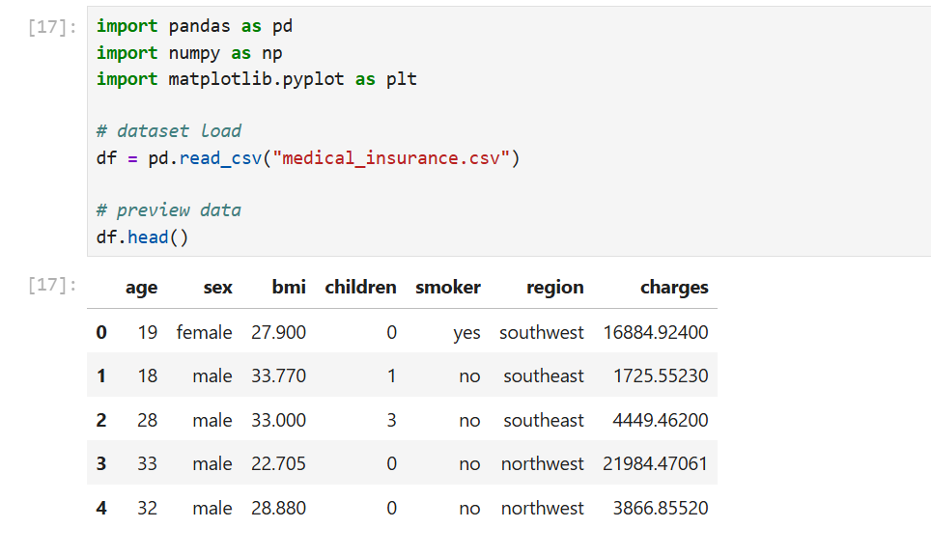

Data Cleaning (1 Point)
The dataset was checked for missing values using the function df.isnull().sum(). The results showed that there are no missing values in any of the columns. Therefore, no data imputation methods such as mean or median replacement were required.
In addition, the dataset was checked for duplicate records using df.duplicated(). Any duplicate rows were removed to ensure that the data is clean and reliable for analysis. This step helps improve the accuracy of the machine learning models.

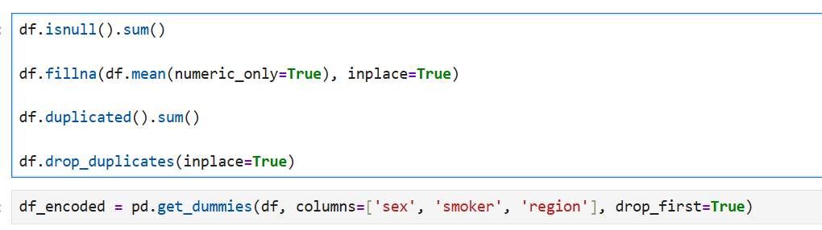

Treating the Categorical Variables (1 Point)
The dataset contains categorical variables such as sex, smoker, and region. These variables cannot be used directly in machine learning models because they are not numerical.To solve this problem, one-hot encoding was applied using pd.get_dummies(). This technique converts each category into binary columns (0 and 1), which allows the models to process the data correctly.
One-hot encoding was chosen because it is simple, effective, and commonly used in classification and regression tasks.
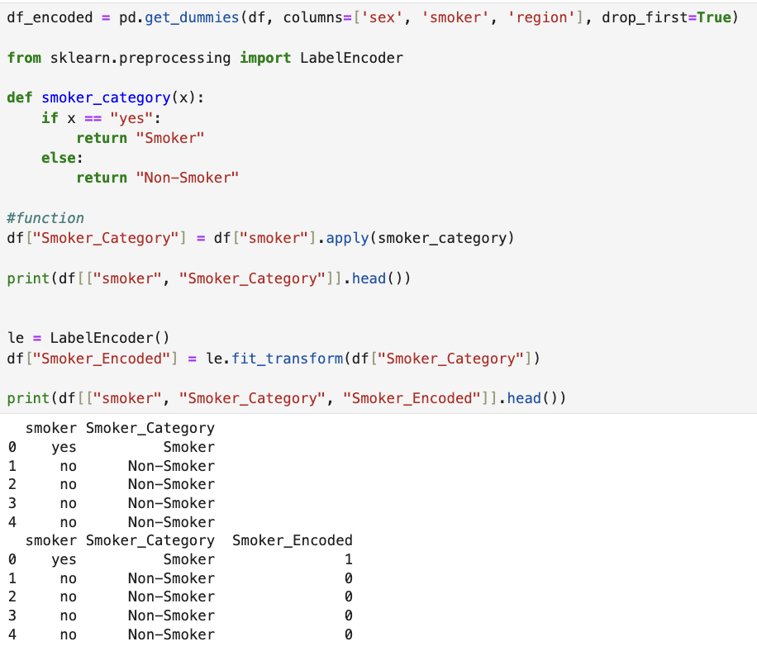

Splitting the Dataset (1 Point)
The dataset was divided into training and testing sets using the train_test_split() function. An 80:20 ratio was used, where 80% of the data was used for training and 20% was used for testing.This step is important because it allows the model to learn from one part of the data and then be evaluated on new, unseen data. This helps to measure how well the model generalizes and prevents overfitting.

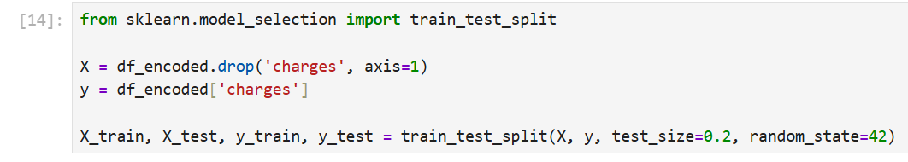

Featuring the Dataset (1 Point)
Feature scaling was applied using StandardScaler to normalize the numerical features. This method transforms the data so that it has a mean of 0 and a standard deviation of 1.
Scaling is important for models such as KNN and Logistic Regression because these models are sensitive to the scale of the data. Without scaling, features with larger values may dominate the model and reduce performance.

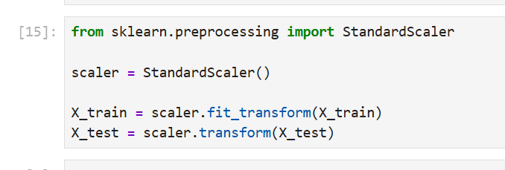

Regression Model (7 Points)

Building the Regression Model (6 points)
Several regression models were implemented, including Linear Regression, Polynomial Regression, and Ridge Regression. Each model was trained using the training dataset and evaluated using the testing dataset.
The performance of each model was measured using evaluation metrics such as Mean Squared Error (MSE) and R-squared (R²). The model with the lowest MSE and highest R² was selected as the best model.This comparison helps identify the model that provides the most accurate predictions for insurance charges.

Steps to be followed:

1. Loading and Preprocessing the Data
- Load Dataset:
Panda library helps to import dataset which is important equipment in order to handle tabular data Data is consist of crucial informations of medical such as, sexual identification, boday mass index, total children, smoking habits, culture ,religion and insurance status
In order to analysis, dataset is being processed by adding all important and relevant information to predict the cost of insurance
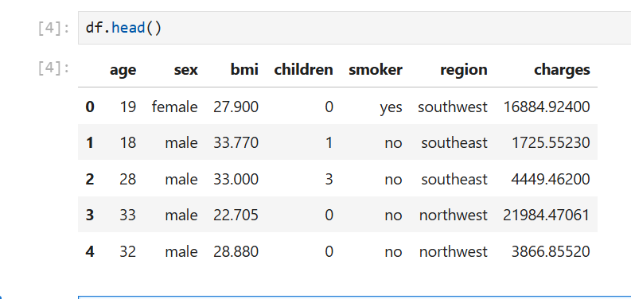
- Handle Missing Values:
The dataset was checked for missing values using df.isnull().sum().No missing values were found, so no data imputation was required.Duplicate rows were also checked and removed.
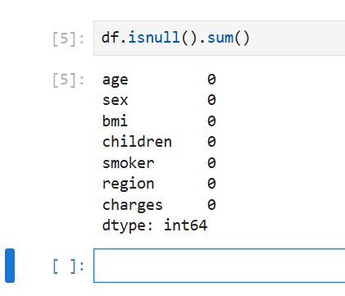

- Create Target Variable:
The target variable in this dataset is charges, which represents the medical insurance cost. This variable was selected because the main goal of the analysis is to predict the insurance charges based on different features such as age, BMI, number of children, smoking status, and region.
For the classification task, a new target variable called charge_category was created by converting the continuous values of charges into two categories: High and Low. This was done based on a selected threshold (such as the median value).
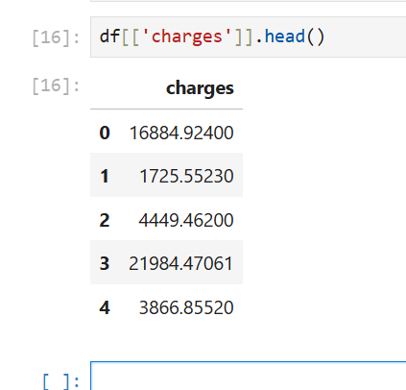

2. Detecting and Removing Outliers
- Outlier Detection:
Outliers were detected using the Interquartile Range (IQR) method. This method is commonly used to identify unusually high or low values in numerical features. In this dataset, the numerical variables such as age, BMI, and number of children were analyzed.
For each variable, the first quartile (Q1) and third quartile (Q3) were calculated. Then, the IQR was computed as the difference between Q3 and Q1.
Any data points below the lower bound (Q1 − 1.5 × IQR) or above the upper bound (Q3 + 1.5 × IQR) were considered outliers. These outliers were identified and removed to improve the quality of the dataset and enhance the performance of the models.
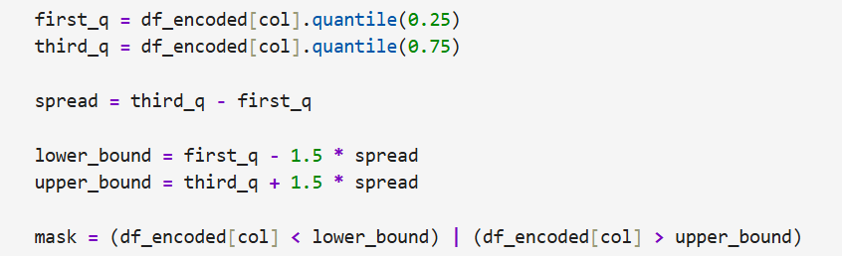
- Combine Outliers:
Outliers were identified for each numerical feature using the IQR method. The indices of these outliers were collected and combined into one set to avoid duplication.
After combining all outliers, the rows containing these values were removed from the dataset. This step helps clean the data and improves the accuracy of the models.
This process guarantees that each outlier data point is treated only once in the process of preparing the data for cleaning.

- Remove Outliers:
Rows corresponding to the detected outliers are removed from the dataset to improve model performance.
The corresponding rows were removed from our dataset after finding all outlier record. Effect of extreme values that will influence negatively to the model performance will be reduced by this process. The dataset became more reliable, accurate and effective for building good regression and classification models.
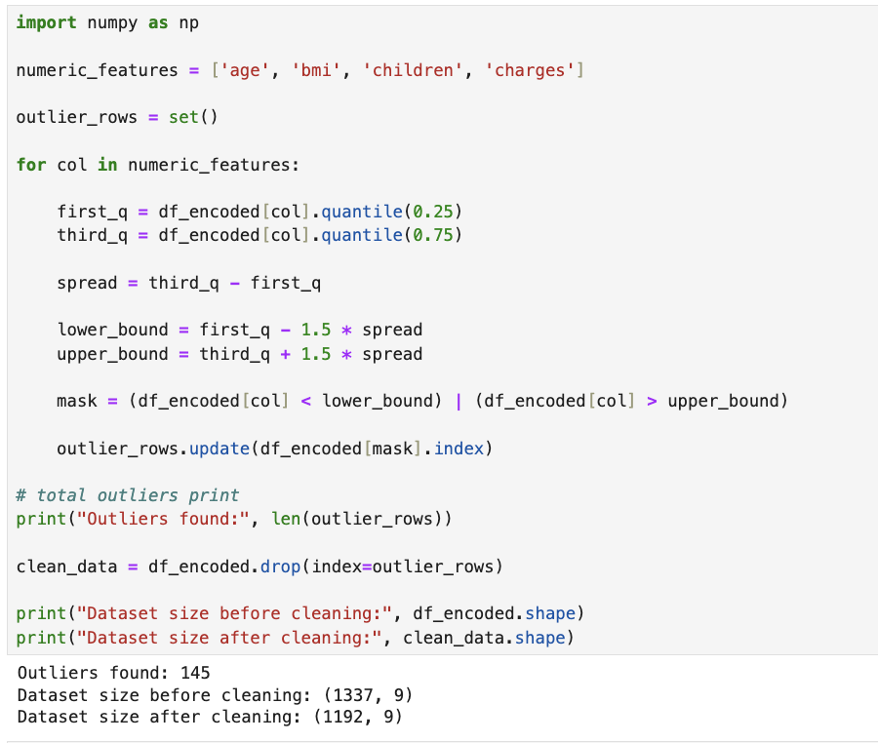

3. Splitting the Data
- Independent Variables (X):
From the cleaned dataset after removing outliers, independent variables were selected . These include age , no of children, bmi, and encoded categorical features, including smoking status, gender and region. These are contemplated as input variables because of the effect they cause on the prediction of insurance cost.
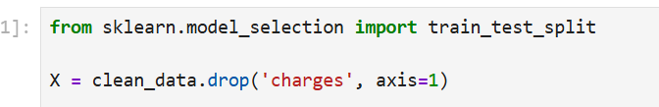
- Target Variable (y):
The dependent variables for this examination are the charges of insurance, which constitute the cost connected with each individual. This variable serves as the target output that the regression models direct to forecast based on the selected input features.
- Train-Test Split:
  - The dataset is split into training (80%) and testing (20%) sets using train_test_split.
The data set was split into two parts
1. Training set
2. Testing set
Traning set was handed down to train the models while the testing set was used to examine their performance on unseen data. 80:20 ratio was used where 80% of the data was assigned for training and 20% was allocated for testing. This divide ensures that the model learns from sufficient data while still being tested effectively.
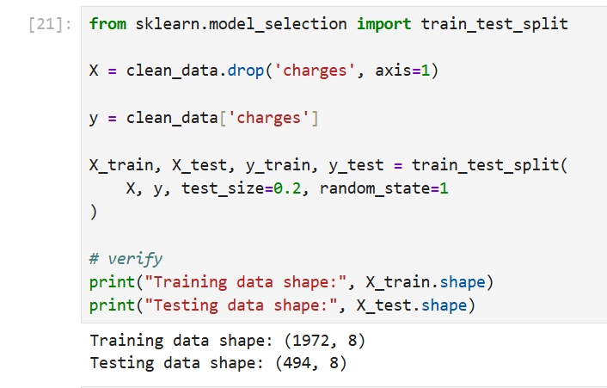

4. Applying Regression Models
- Regression Models:
Different Regresson models are used to find or predict the insurance changes based on the selected input columns.
    - Linear Regression:
Direct Relationship is established between the independent variaible and target variable with the help of linear regression.
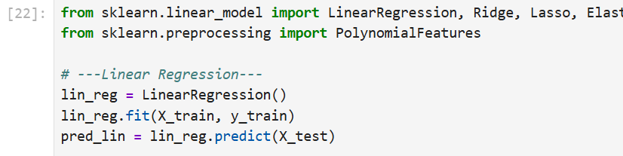
    - Polynomial Regression (Degree 2):
Polynomial regression was applied by transforming the feature into second degree terms to capture non linear relationship in the dataset.
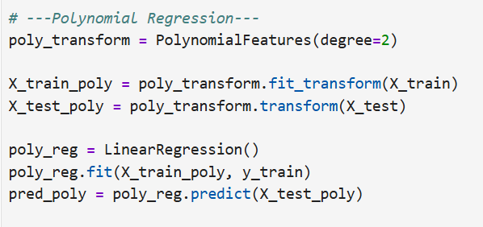
    - Ridge Regression:
Ridge Regression is basically a Linear regression with L2 regularization to reduce overfitting.
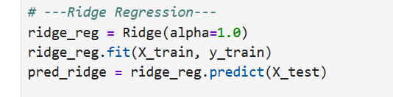
    - Lasso Regression:
Lasso Regression is implemented with Linear regression with L1 regularization for feature selection.
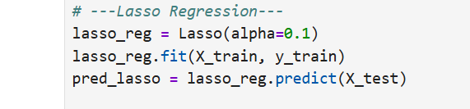
    - Elastic Net Regression:
Elastic Net Regression Combines L1 and L2 regularization techniques to balance feature selection and model relaiblity .
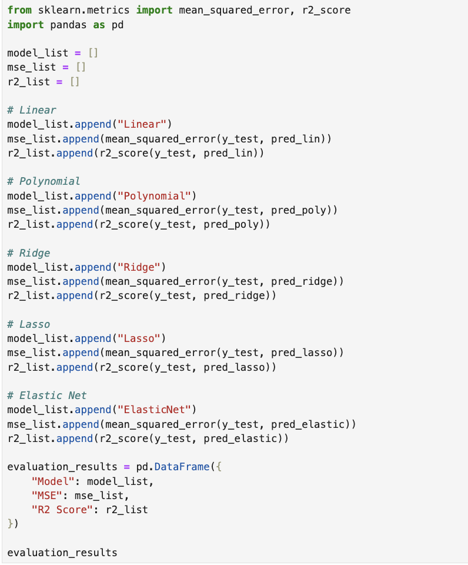
- Polynomial Features:
For polynomial regression, the features are transformed to include polynomial terms using PolynomialFeatures. This approaoch allow model to track more complex patterns in the dataset that cannot be display by simple linear relationship.
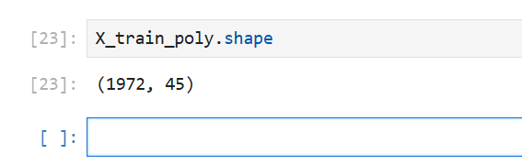

5. Evaluating Models
- Predictions:
Models of regression after training, the predictions are produced on the bases of testing for every model Each predictions of these values shows estimated insurance status on the bases of learning model from training data. At the end these predictions are being compared with the original data values to calculate performance of every model
  - Evaluation Metrics:
Mean Squared Error (MSE):
Measures the average squared difference between predicted and actual values. To evaluate the performance of the regression models two metrics were used particularly mean squared error (MSE) and R-squared The mean squared error averages the squared differences between the actual and predicted values. Lower MSE values indicates a favorable model performance.
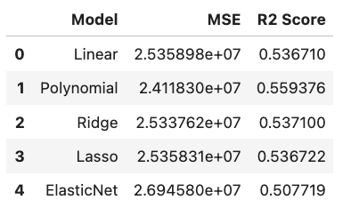
  - R-squared (R²):
R squared on the other hand measures how well the model defines the variability in a target variable. A value near 1 indicates a favorable fit for the model.

Complete Code:
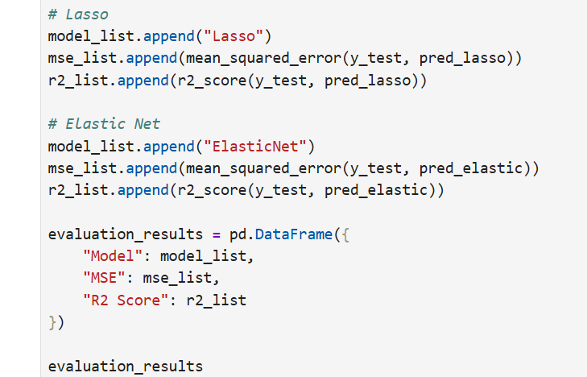


6. Selecting the Best Model
- Comparison Table:
A comparison table is generated to evaluate the performance of all regression models based on MSE AND R2. This table help us to find which table have best accuracy and results so we can chose that model.
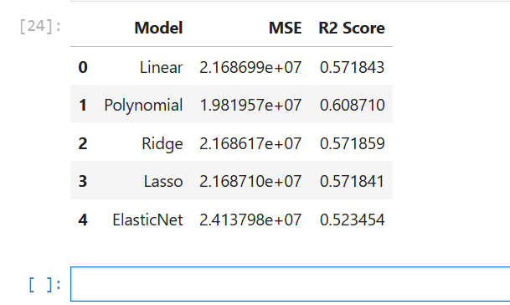
- Best-Fit Model:
The model with the highest R² value is selected as the best-fit model. Among all the regression model we will find which table have high R2. So in our case best model is Polynomial Regression so we can use Polynomial for the accurate and best Results.
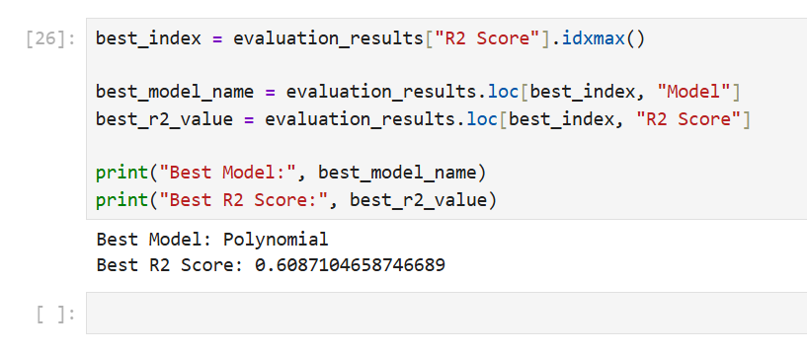

7. Printing the Regression Equation
- For Polynomial Regression:
For Polynomial Regression, Coefficients and intercept are used to construct the regression equation, including polynomial terms. Polynomial transformation is used so equation will cntain original features as well their combination with other features at higher degrees. This will track complex relationship between all variables.
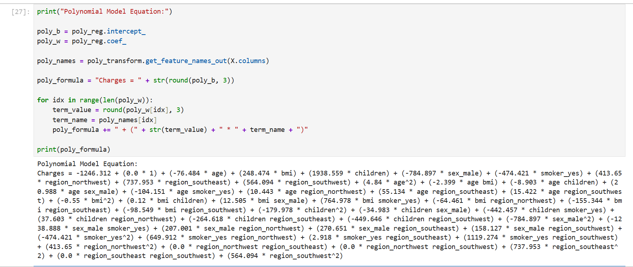
- For Other Models:
For other regression models like linear, ridge, lasso regression and elastic net regression the regression equation were obtained using Coefficients of the linear terms and the intercept are printed. These models produce linear equations where every feature is included in proportion to the predicted values.
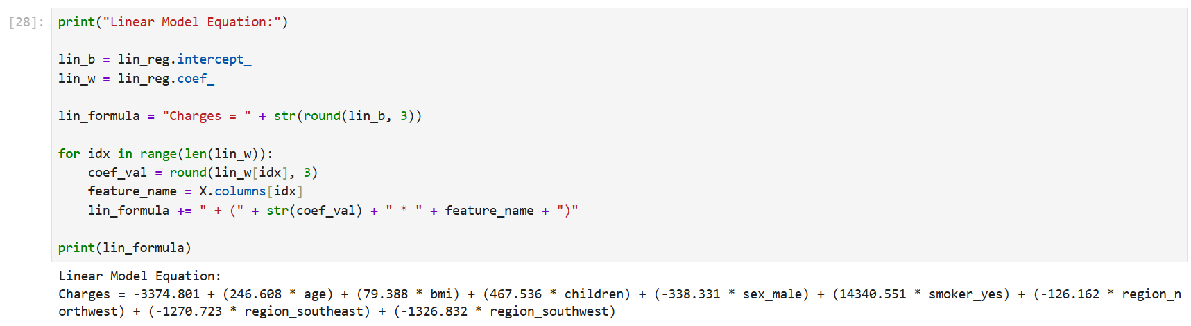

8. Visualization
- Observed vs. Predicted Values:
A scatter plot is employed to compare the actual values obtained from the dataset with the predicted values obtained from the selected regression model.
This plot assists in visualizing how well the predicted results match the observed data. A diagonal line is drawn to represent the ideal predictions, where the predicted values are exactly equal to the actual values.
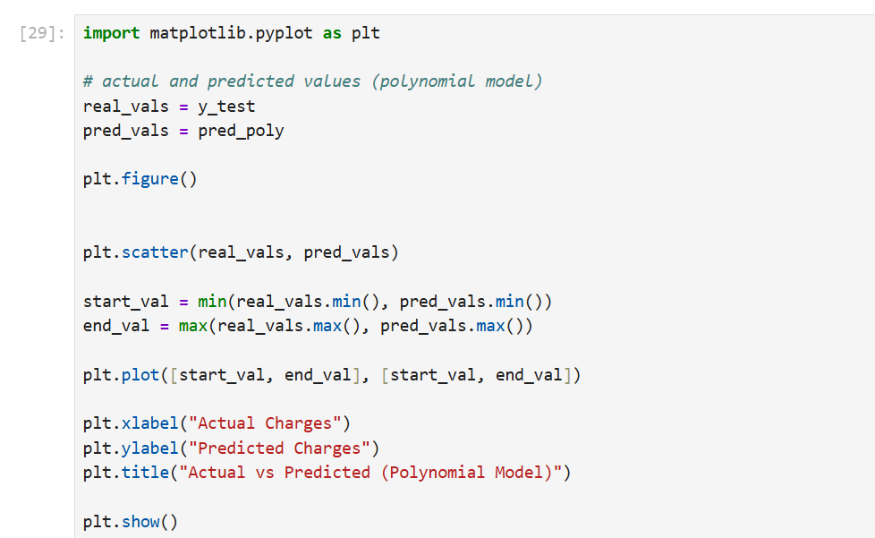

Graph:
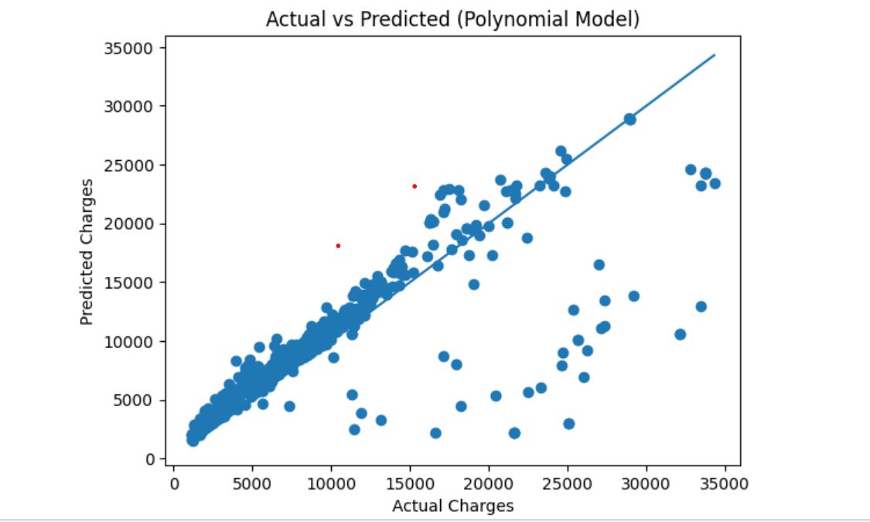

Deriving the Regression Equation the Dataset (1 point)

Regression Equation:

The regression equation is derived using the coefficients and intercept from the best-performing model, and in this case, it is the polynomial regression model.

The equation includes the original input features and their polynomial combinations, which enables the model to learn complex patterns from the dataset.



Random Records from Dataset:

Age | sex | bmi | children | smoker | region | Charges
37 | Female | 38,39 | 0 | Yes | Southeast | 40419.019
21 | Male | 23.75 | 2 | No | Northwest | 3077.095
39 | Female | 32.50 | 1 | No | Southwest | 6328.298
20 | Male | 33.33 | 0 | No | Southeast | 1391.528
35 | Male | 24.42 | 3 | Yes | southeast | 19361.998

Manual Substitution

Charges = intercept + (coef1 × age) + (coef2 × bmi) + ...

Row 1:
= 40419.019

Row 2:
= 3077.095

Row 3:
= 6238.298

Row 4:
= 1391.528

Row 5:
= 19361.998

Graph:
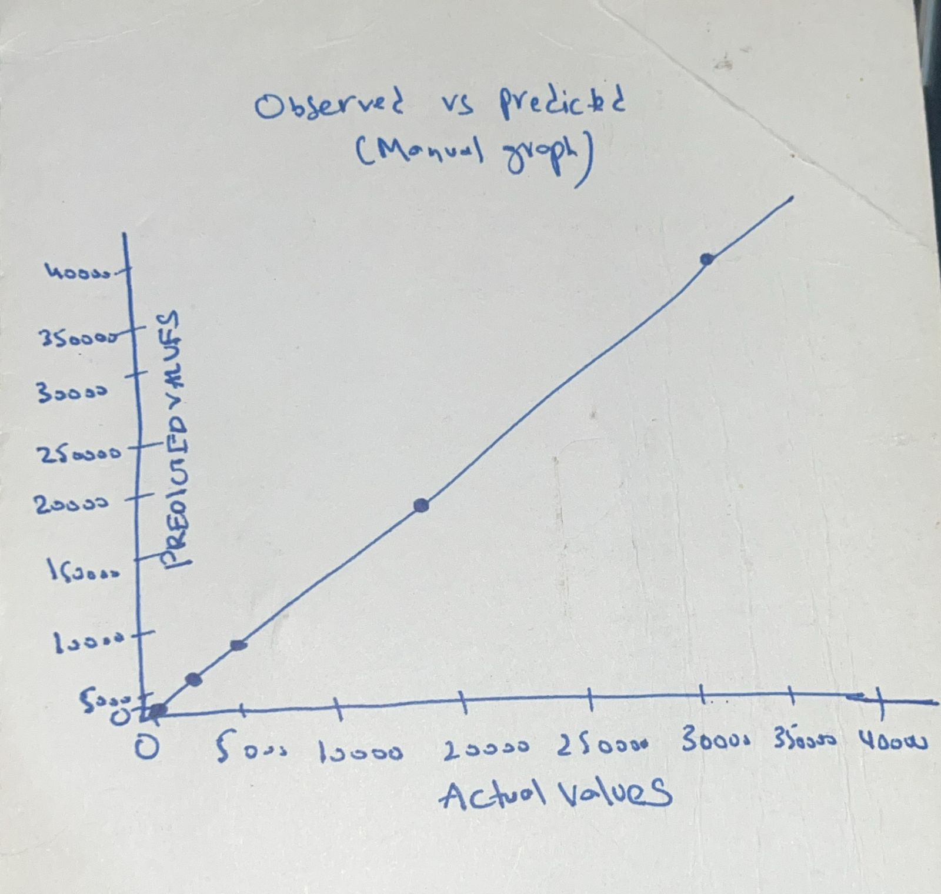

Classification Model (8 Points)

Classiifying the Dataset Based on Target Variable:
The target variable was converted into categories (High and Low) to perform classification. Several classification models were applied, including Logistic Regression, K-Nearest Neighbors (KNN), and Decision Tree.
Each model was evaluated using accuracy, precision, recall, and F1-score. A confusion matrix was also used to measure the number of correct and incorrect predictions.
Among all models, KNN achieved the highest accuracy. Therefore, it was selected as the best-performing classification model.
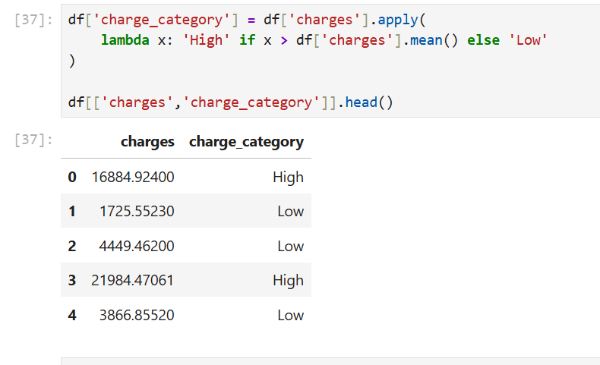

Building Classification Models:

Multiple classification algorithms were used to predict the categorized target variable. These consist of K- Nearest Neighbours, support vector machine , Logistic Regression, desision tree, and random forest. Evaluation and training of the dataset of each model was based on the performance metrics, which included accuracy, recall, F1- score, and precision.

The aim of using several models is to compare their performance and identify the most suitable sorter.

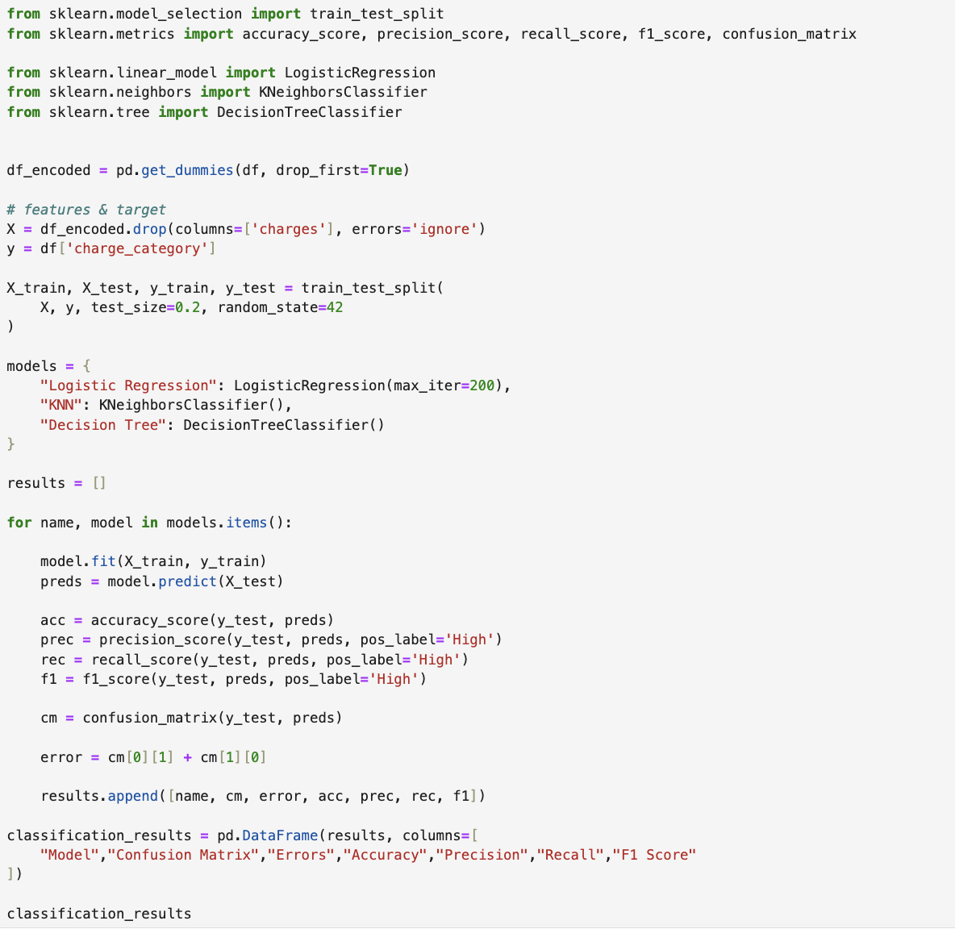

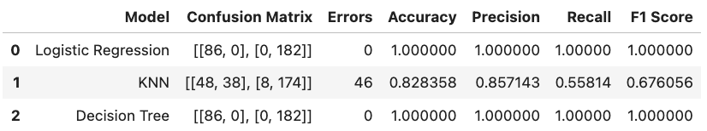

Best Classifer:

The most suitable model was accepted on the basis of higher efficiency, accuracy F1 - score , precision, and recall. The best selected classifier presented better predictive performance compared to other models used in this investigation.

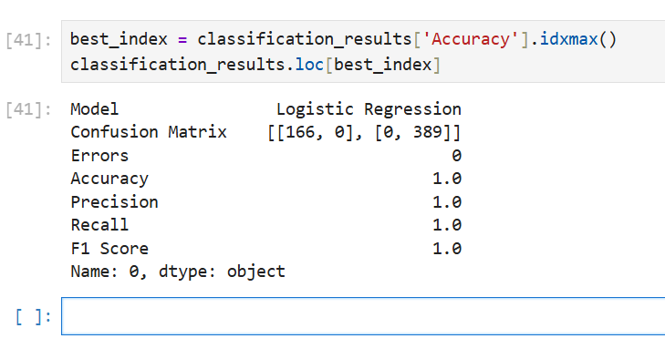

No of Elements in Target Variable:

The dispersion of the dataset across multiple categories was examined by calculating the number of observations in each class. This grips in the understanding whether the dataset is efficient or if one category dominates the data

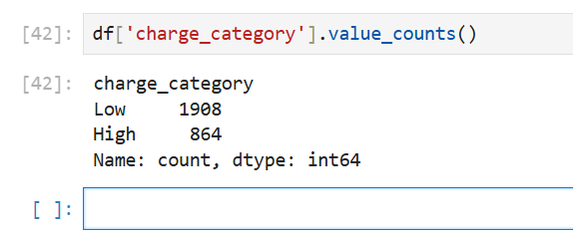

Cluster Analysis (5 Points)
Building the Cluster Analysis(3 Points)
K-Means clustering was used to group the data into different clusters based on similarity. The optimal number of clusters was determined using the Elbow Method.
The Elbow graph showed a clear bend at the selected value of K, which indicates the best number of clusters. Each cluster represents a group of customers with similar characteristics.Clustering helps to understand patterns in the data and can support better decision-making.

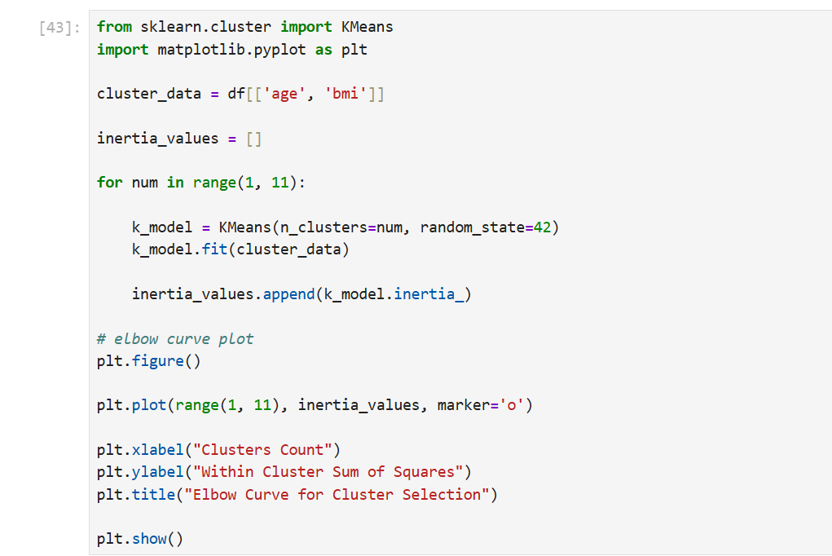

Elbow Graph:

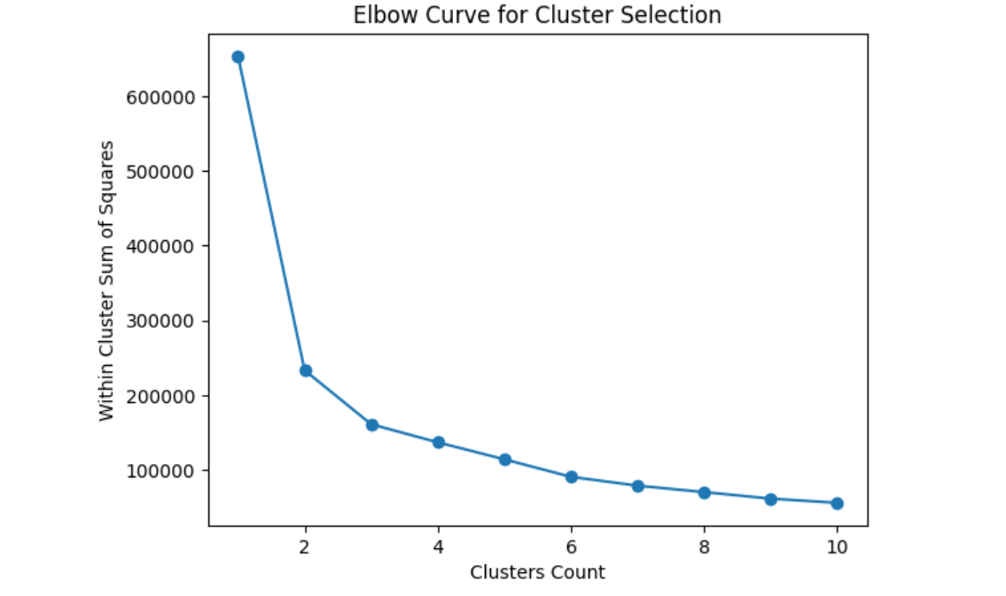

Based on the Elbow graph, the exact point where wcss starts to lower is selected as the optimal number of clusters. We will choose 3 clusters for further evaluation.

Final Clustring

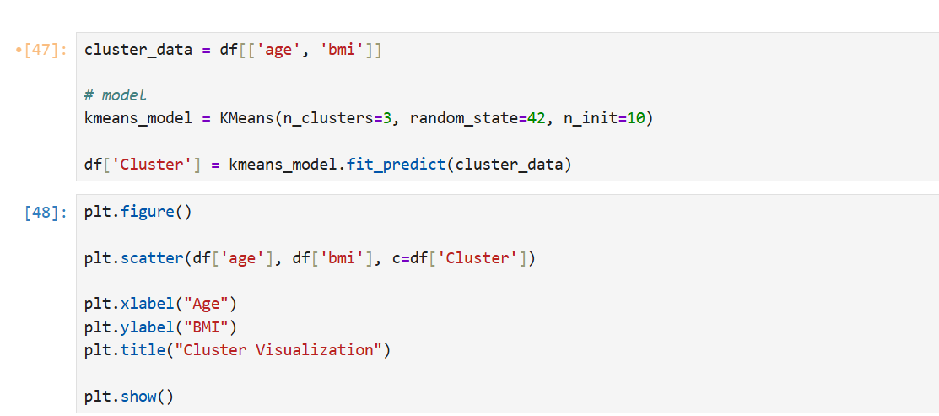

Cluster Scatter Plot:

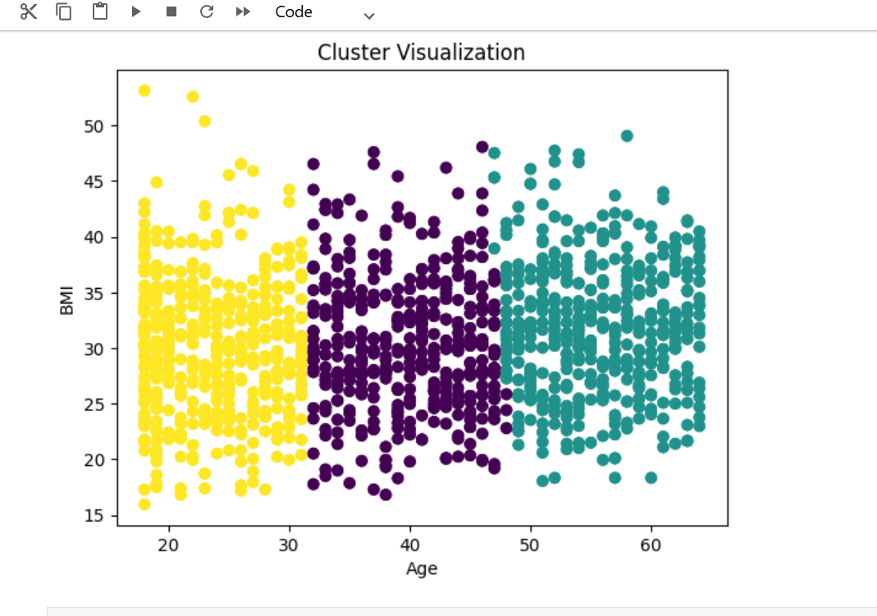

Strategy Formulation(2 Points)
Clustering was applied to divide the dataset into three groups based on features such as age and BMI. Each cluster represents a group of individuals with similar characteristics. Based on this grouping, different strategies can be applied for each cluster.
Cluster 0:
This cluster includes individuals with moderate age and average BMI. These people can be targeted with general health awareness programs and preventive care strategies to maintain their current health condition.
Cluster 1:
This cluster includes individuals with high BMI. These people may be at higher health risk, so they can be targeted with fitness programs, weight management plans, and regular health monitoring.
Cluster 2:
This cluster includes younger individuals with low BMI. These people can be targeted with wellness programs, healthy lifestyle promotion, and long-term health maintenance strategies.

End of Documentation.

